Student Management System
Technical Story Card

Revision History
Version No. | Date | Prepared by / Modified by | Significant Changes
1 | 24-02-2022 | Prakash | Introduction
2 | 24-02-2022 | Neethu Davis | Use Case model
3 | 24-02-2022 | Najula M N | Scope of Change
4 | 24-02-2022 | Harish | Flow Chart
5 | 15-03-2022 | Prakash | Use Case model modified
6 | 15-03-2022 | Najula M N | Updated tables under case model
7 | 17-03-2022 | Neethu Davis | ER Diagram
8 | 20-03-2022 | Najula M N | Class diagram
9 | 23-03-2022 | Prakash | Reference
10 | 26-03-2022 | Najula M N | Use Case model modified
11 | 26-03-2022 | Prakash | Sequence diagram modified
12 | 27-03-2022 | Najula M N | Use case models updated

Glossary
Abbreviation | Description
BSC | Business Story Card
TSC | Technical Story Card
DOJ | Date of Joining

Table of Contents
1 Introduction 5
2 Scope of Change 5
3 List of impacted modules 5
4 Design and Detailed technical updates 6
4.1 Process model 6
4.1.1 Use case Model 6
4.1.2 Sequence diagram 8
4.1.3 Architecture diagram 9
4.1.3.1 Presentation layer………………..………………..……………………………10
4.1.3.2 Application layer……………………..…..…………………..............…....…...10
4.1.3.3 Data layer……………………………………………………..…………….…..10
4.1.4 Class diagram 11
4.2 Proposed user Interface design 12

4.2.1 Home page ………………………………………………………………………....12
4.2.2 User Registration page ………………………………..……………………....13
4.2.3 User Login page ………………………………..…………………………….....14
4.2.4 Add new Student ………………………………..…………………………….....15
4.2.5 Update Student ………………………………..…………………………….....16
4.2.6 Find Student ………………………………..…………………………….....17
4.2.3 Delete Student ………………………………..…………………………….....18
4.3 Database design changes 19
4.2.1 ER Diagram………………………………………………………………………....19
5 References 20

Introduction
This software application stores all the student's information in a database. It is an application developed in Java and the database used is SQL. It contains student information like student id, name and date of admission.
It is an easy-to-use application and has a user-friendly interface. It is totally built at the administrative end which means that only the admin has access rights to change or modify any records. So, this makes it a safe and reliable application to use. The main aim of developing this application was to reduce the errors that occur in the manual system.
One can search the details easily by just entering a student id. In earlier systems, there was not such a facility to do so. All the details are stored in an SQL database. It is easy to update any student details. All the student records are integrated and so this makes it a user-friendly and easy to use application.

Scope of Change
We can add registration for new student. We can include new student registration in this project in the future. We can also include some other options like generating progress report and course details in the form of pdf once the updations are done in the project.
.

List of impacted modules
All the functional modules will be created from scratch.

Design and Detailed technical updates

Process model

Use case Model

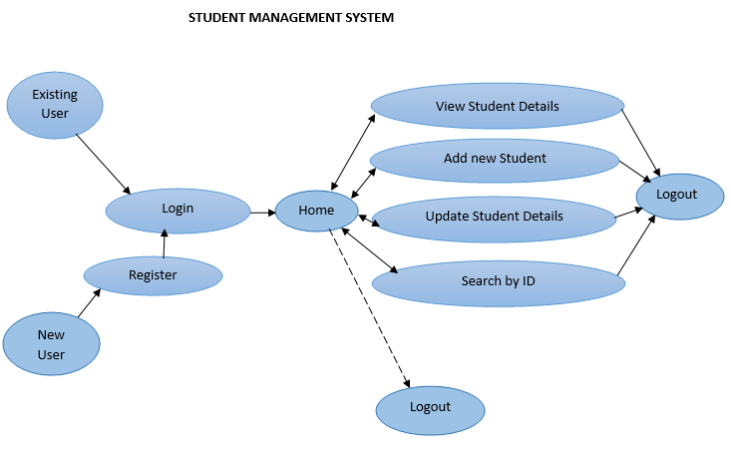

Brief Description | User operations in Student management system
Basic Flow | - New user can register into the system. After successful registration, user have to login to the system.  - Existing user can login to the system and can perform:  - Add new student details  - Update student by ID  - Delete student by ID  - View student details  Using any of these options’ user will interact with the application. It will display the student list, marks, division and pass or fail.
Alternate Flow | The system will validate the information provided.  If any invalid data is found, the input form will be redirected with error message.
Validation | Student name/Roll no/DateOfAdmission is required.  Contact number must be of 10 numbers.
Pre-Conditions | User should have network access and Browser with latest updates.
Post-Conditions | Success message should be shown.

Sequence diagram

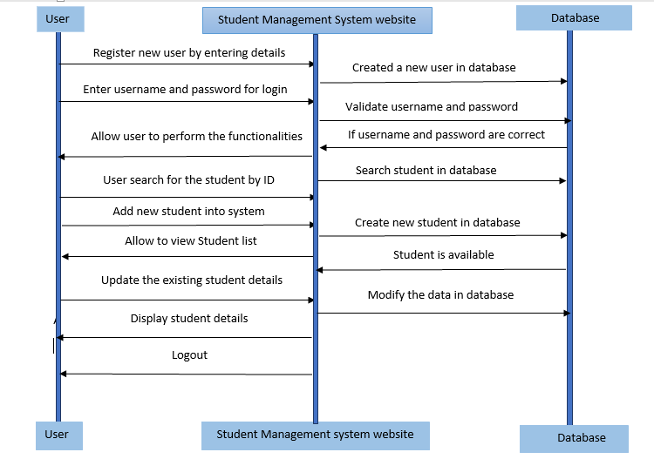

Architecture Diagram

Oracle
Database

Layer

Logical View

Technology/ Framework

Login
Add new Student
Search by ID

Update details
Presentation Layer

HTML/ CSS/ TypeScript/ Angular

Application/ Business Layer

Web-Server Classes

Configuration

Controllers

Service

REST Controllers

Entity/ Model Classes

Java 1.8/ Spring MVC

Data Access Layer

Repository classes

UI Components

Spring JPA

Presentation Layer:

This layer consists of all UI components.
- Login Component: User can login to the system with valid username and password.
- Add new Student component: User can add or register a new student to system with valid details.
- Search by ID: User can search a student by ID.
- Update details: User can update existing student details into system.
- Delete by ID: User can delete the student details from system using student ID.

Application Layer:

This layer comprises of all server and business classes.
- Configuration settings (XML or Class based) will define the application and server configuration.
- Spring Controllers defines the server classes, which are required to process the incoming http requests.
- Service classes are required to perform the required business services.
- REST Controllers to process the HTTP AJAX requests.
- Model classes are used the define the functions of the entities present in the system.

Data Layer:

Data layer is implemented through Spring JPA. It will contain the repository classes, which provides interface to the table.

Class Diagram
Angular Application

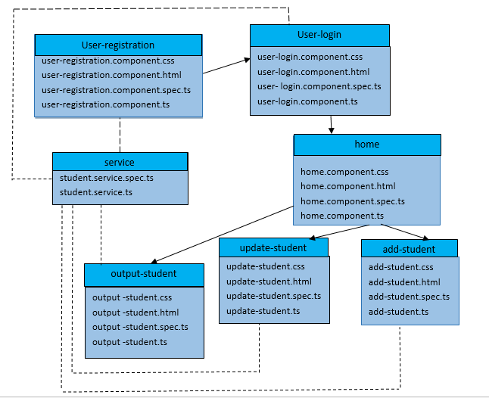

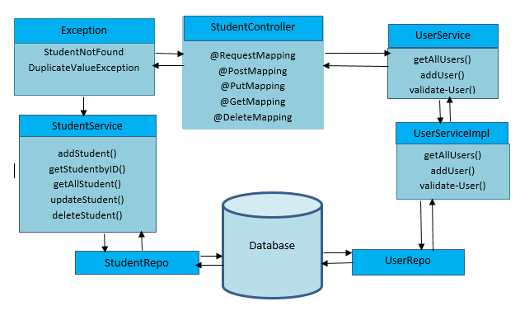
Spring Boot Application

Proposed user Interface design
    - Home Page:
Brief Description | Home Page
Basic Flow | This page describes 3 options  1.The student can view the details.  2. The student can do the add student.  3. The student can find the details using student ID  4. The student can delete the details using student ID
Alternate Flow | The system will validate the credentials provided.
Validation | The ID entered should be in integer datatype.
Pre-Conditions | student should have network access and Browser with latest updates.
Post-Conditions | Corresponding page has to be displayed.

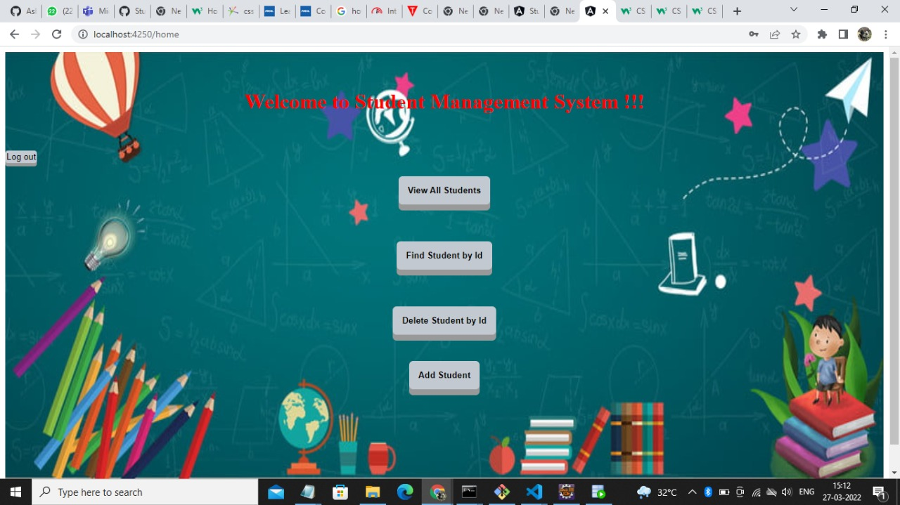

    - User Registration:

Brief Description | User Registration
Basic Flow | This use case describes how a User can register into the system  - The following information is required during registration.  - Staff’s Name  - Email ID  - Address  - Contact Number  - Username and Password
Alternate Flow | - The system will validate the information provided and create new user details into the system.
Validation | - Name is required and minimum 3 characters and max 30 characters.  - Email ID can be alphanumeric and valid.  - Address can be alphanumeric  - Contact number is of 10 digits only, required field  - Username and Password must be created.
Pre-Conditions | User should have network access and Browser with latest updates.
Post-Conditions | After Successful registration, user have to login into the system.

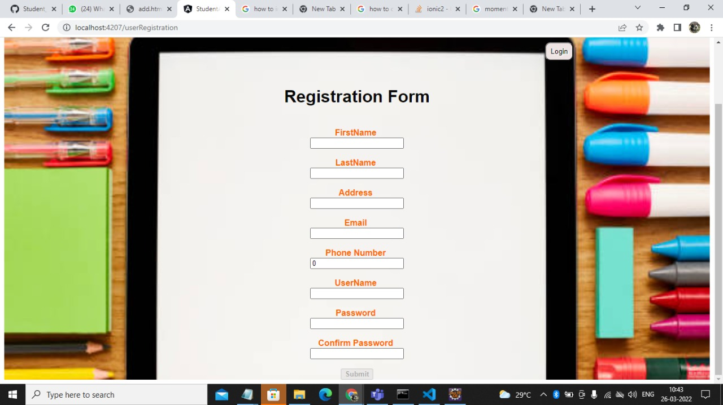

    - User Login:

Brief Description | User Login
Basic Flow | This use case describes how a user gets into user profile.  - The user has to login into the system.  - After the successful login, user will redirect to appropriate landing page.  - The following information is required to login.  - Username  - Password
Alternate Flow | - The system will validate the credentials provided. If credentials are invalid, login form will be redirected to create the profile or give alert that invalid user.
Validation | - Valid username  - Valid password
Pre-Conditions | User should have network access and Browser with latest updates.
Post-Conditions | User can do next operations as per their requirements.

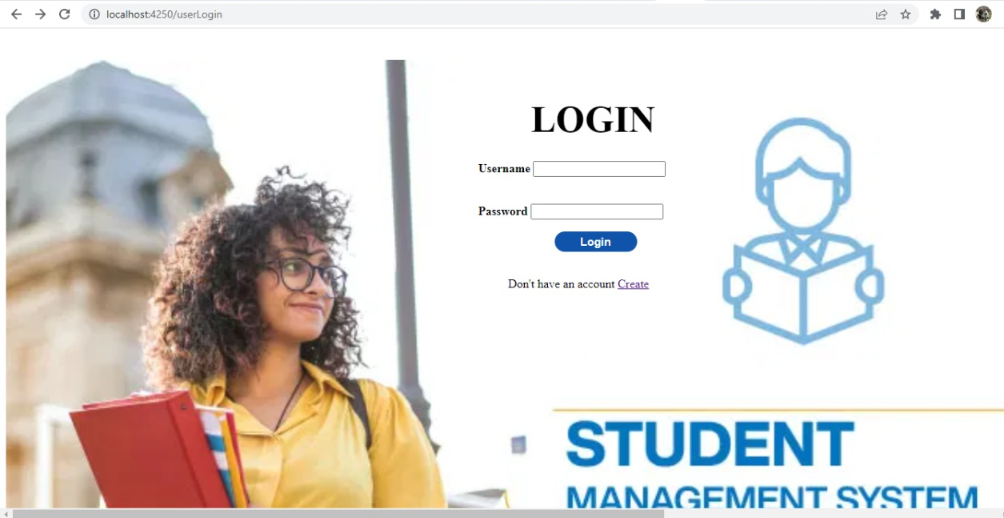

    - Add new Student:

Brief Description | Add new Student – Student Registration
Basic Flow | This use case describes how a student profile is created by into the system  - The user should enter the details in the form.  - The following information is required during registration.  - Student Name and Roll No.  - DOA  - Subject marks
Alternate Flow | - The system will validate the information provided. If any invalid data is found, the input form will be redirected with error message.
Validation | - Name is required and minimum 3 characters and max 30 characters.  - Roll no. required and in alphanumeric.  - Subject marks minimum 1 characters and max 3 characters.
Pre-Conditions | Student details aren’t added to the system before.
Post-Conditions | Success message should be shown.

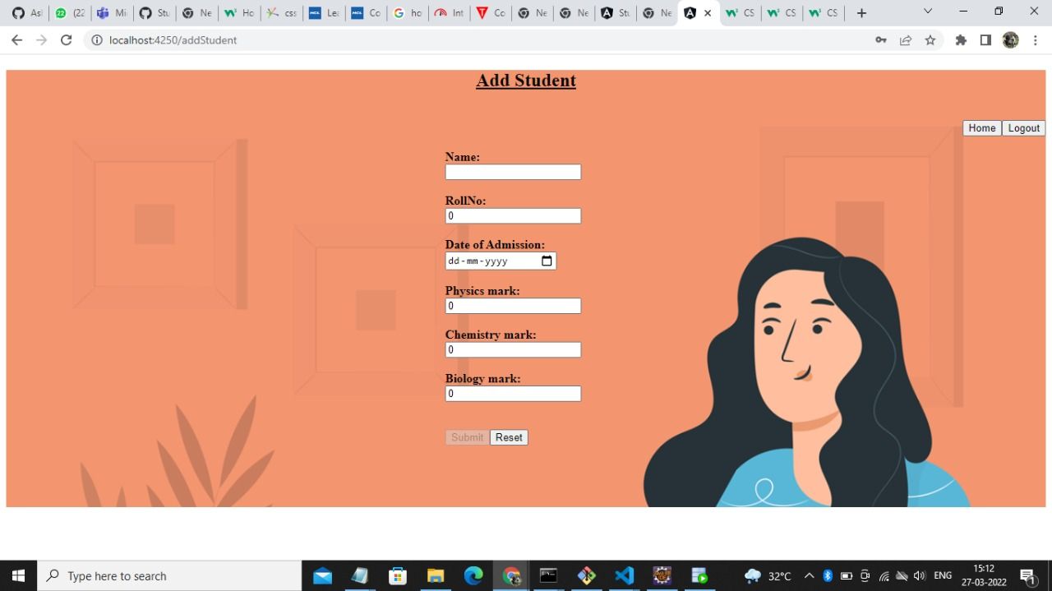

    - Update Student:

Brief Description | Update Student
Basic Flow | This use case describes how a student profile can by updated by the user into the system  1.The user student should enter the details in the form.  2.The following information is required during updating.  - Student Name and Roll No.  - DOA
Alternate Flow | The system will validate the information provided. If any invalid data is found, the input form will be redirected with error message.
Validation | Name is required and minimum 3 characters and max 30 characters.  Roll no. required and in alphanumeric.  Subject marks minimum 1 characters and max 3 characters.
Pre-Conditions | Student details aren’t added to the system before.
Post-Conditions | Success message should be shown.

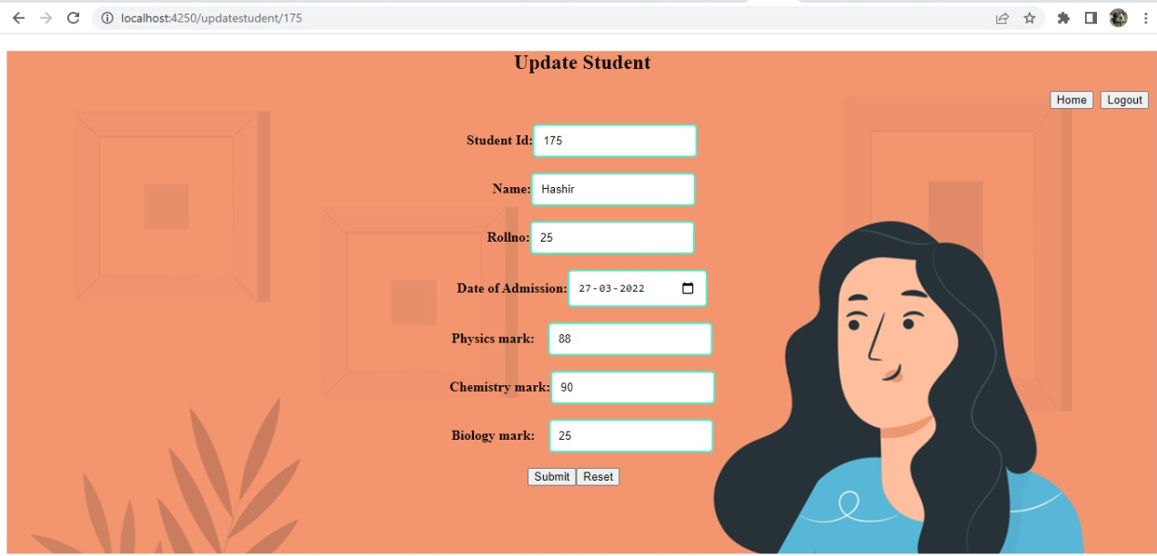

    - Find Student by ID:

Brief Description | View Student by ID
Basic Flow | This use case describes how a student profile can be viewed by the entering the ID.  1.The user student should enter the Student Roll no details in the form.
Alternate Flow | The system will validate the information provided. If any invalid data is found, the input form will be redirected with error message.
Validation | Roll no. required and in alphanumeric.
Pre-Conditions | Student details aren’t added to the system before.
Post-Conditions | Success message should be shown.

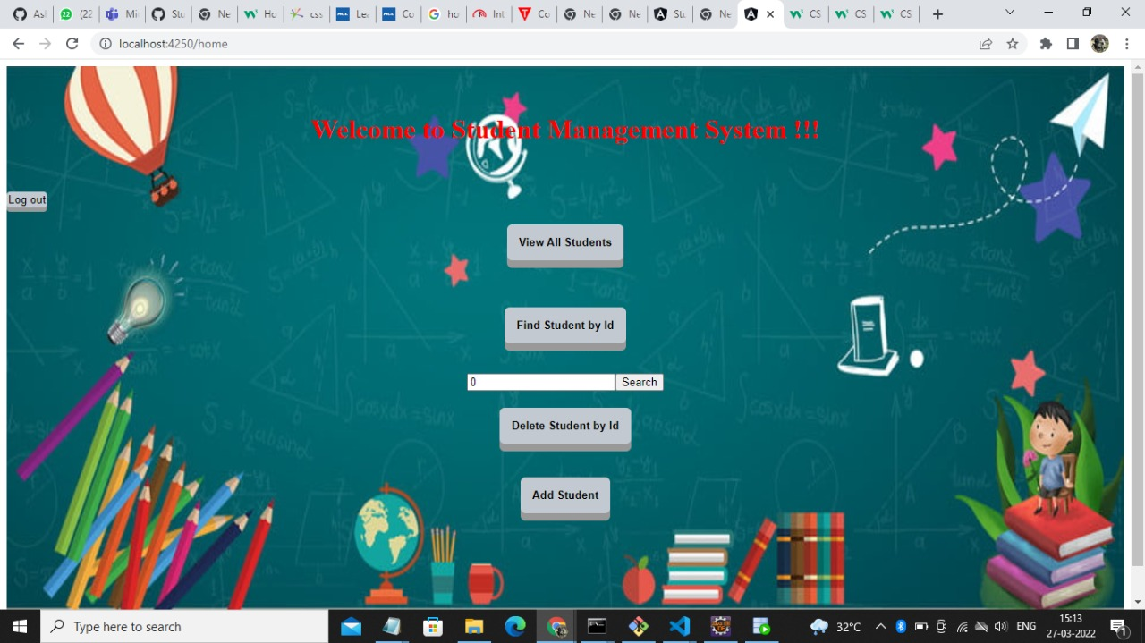

    - Delete Student by ID:

Brief Description | Delete Student by ID
Basic Flow | This use case describes how a student profile can be deleted by user by the entering the ID from the system.  1.The user student should enter the Student Roll no details in the form.
Alternate Flow | The system will validate the information provided. If any invalid data is found, the input form will be redirected with error message.
Validation | Roll no. required and in alphanumeric.
Pre-Conditions | Student details aren’t added to the system before.
Post-Conditions | Success message should be shown.

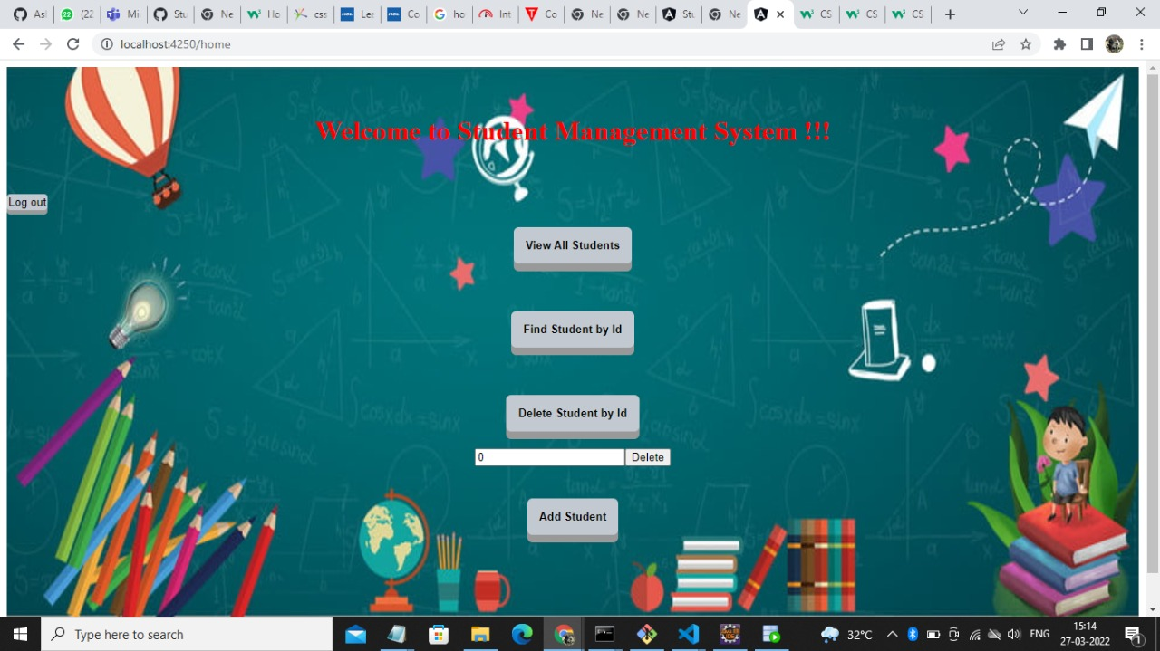

Database design changes
<Provide the logical design of the base data structures used to store the data. Eg Like tables, and views or entities and relationships>

ER DIAGRAM

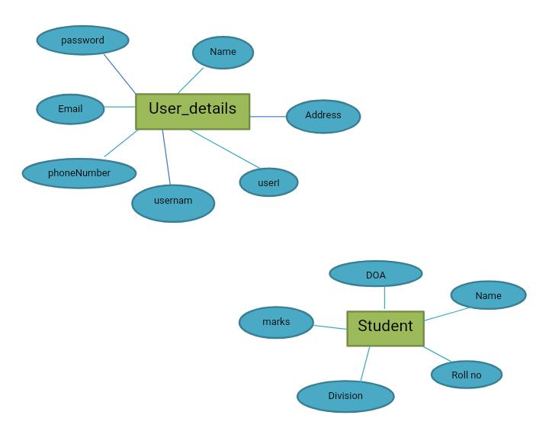

References
We as a team have used references to LMS content to complete our project of “Student Management System”. HCL provide the three months training for us. On that particular training we learnt so many technologies like core java, HTML, CSS, spring boot, Angular8 . What all we learnt in the training we implement in our project.

